
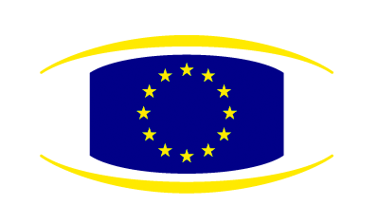
Brussels, 11 February 2010

Statement by the

Heads of State or Government

of the European Union

All euro area members must conduct sound national policies in line with the agreed rules. They have a shared responsibility for the economic and financial stability in the area.

In this context, we fully support the efforts of the Greek government and their commitment to do whatever is necessary, including adopting additional measures to ensure that the ambitious targets set in the stability programme for 2010 and the following years are met. We call on the Greek government to implement all these measures in a rigorous and determined manner to effectively reduce the budgetary deficit by 4% in 2010.

We invite the Ecofin Council to adopt at its meeting of the 16th of February the recommendations to Greece based on the Commission's proposal and the additional measures Greece has announced.

The Commission will closely monitor the implementation of the recommendations in liaison with the ECB and will propose necessary additional measures, drawing on the expertise of the IMF. A first assessment will be done in March.

Euro area Member states will take determined and coordinated action, if needed, to safeguard financial stability in the euro area as a whole. The Greek government has not requested any financial support.

____________________

