Treaty-based ISDS cases brought under Dutch IIAs:
An Overview

An overview study by UNCTAD/DIAE, commissioned by the DG Foreign Economic Relations, Ministry of Foreign Affairs, the Netherlands

KEY FINDINGS

- By the end of 2013, Dutch investors had initiated a total of 61 known treaty-based cases against foreign governments.

- The great majority of claims (52 claims) were filed under Dutch bilateral investment treaties (BITs), while 9 claims were brought pursuant to the Energy Charter Treaty (ECT), a specific plurilateral treaty for energy-related matters to which the Netherlands is a party.

- The 54 cases initiated by Dutch investors by end of 2012, represent 10 per cent of the global number of known cases and account for one-fifth of all claims filed by investors from the European Union (EU).

- Claims by Dutch investors are most often directed against respondent States in Latin America, in the EU and in Asia. Venezuela (13 claims) and the Czech Republic (6 claims) are the most frequent respondents.

- Claims under Dutch BITs are primarily brought by companies (legal persons) but there are also examples of claims by individuals (physical persons).

- Investors bringing cases under Dutch BITs vary and include, among others, major Dutch companies, Dutch claimant companies which are part of major TNCs, or smaller and less known companies.
- In around three quarters of Dutch cases, the ultimate owners of the claimants are not Dutch. In two-thirds of those cases, the relevant foreign-owned group of companies does not appear to engage in substantial business activities in the Netherlands.

- The circumstances surrounding each case are highly individualized, ranging from "classic" scenarios such as direct expropriations and issues related to the countries' economic transition (e.g. privatisations), to more unique issues, such as the alleged driving of an enterprise into bankruptcy.

- Some cases involve public services or other social issues, such as the provision of water, health insurance policy or waste management.

- Some proceedings are confidential which makes it difficult or impossible to obtain any information about those cases. In a number of cases, investors' and governments' reactions to the outcome of a particular case are unknown.

- Out of 54 cases initiated by Dutch investors by end of 2012, 17 are currently pending, and 37 are concluded.

- Out of the 37 concluded cases, 17 were settled by the disputing parties.

- Out of the 20 remaining cases, 11 were decided in favour of the respondent States (either at the jurisdiction or at the merits stage).

- Out of 12 cases that completed the merits stage, the tribunal found treaty breaches in 8 of them, while in 4 cases no treaty breaches were found.

- For the 8 cases were treaty breaches were found, the respondent was found to have violated the clause on expropriation in 5 cases, followed by the clause on fair and equitable treatment (FET) in 4 cases.

- The amount of damages awarded to investors can be significantly lower than the amount they claim. One of the known settlements suggests that settlements may involve large pay-outs.

INTRODUCTION

This study gives an overview of investor-State dispute settlement (ISDS) cases initiated by Dutch claimants under international investment agreements (IIAs) to which the Netherlands is a party, hereinafter "Dutch cases". Annex 1 contains a full list of known Dutch cases (61 cases), including those initiated during 2013.

Part I of the study provides a statistical analysis of all known Dutch cases initiated by the end of 2012 (54 cases).

The analysis focuses on:
- trends over time in filing disputes;
- the respondent States (including their regional distribution and the level of development (UN and World Bank classifications));
- the ultimate ownership of the investors;
- the arbitral forums resorted to;
- the IIA provisions invoked and breaches found; and
- the outcomes of the cases.

Where global data is available, the study compares the specificities of the Dutch cases to the relevant situation for all cases brought globally. The analysis in Part I is based on UNCTAD's database of ISDS cases.

Part II of the study provides a more detailed review of 21 selected Dutch cases. Information on these cases is presented in table format (Annex 2) and accompanied by a short listing of initial findings. For that purpose, research was undertaken by UNCTAD's IIA Team, with a view to complementing the information already contained in UNCTAD's database of ISDS cases. This part of the study does not include an examination of Dutch arbitration cases brought under the Energy Charter Treaty (ECT).

Part III concludes.

PART I. STATISTICAL OVERVIEW

By end of 2013, Dutch investors had initiated a total of 61 treaty-based international arbitrations against foreign governments ("Dutch cases", see Annex 1). These are cases whose existence has become public knowledge. The total number of cases is likely to be higher due to confidentiality reasons.

This part of the study covers arbitrations initiated by end of 2012 (i.e. 54 cases); information for 2013 is too sketchy for statistical analysis.

The 54 known cases are international arbitration claims brought by investors of Dutch nationality (companies or individuals) pursuant to IIAs. The IIAs concerned include BITs concluded by the Netherlands with other countries (48 cases, i.e. 89 per cent) as well as the ECT (6 cases, i.e. 11 per cent).

1. Number of cases over time

IIA-based ISDS cases were largely non-existent until the late 1990s and started to grow rapidly from the early 2000s. In this regard, the steep upward trend in Dutch cases is by and large consistent with the global trend.

Dutch cases represent about 10 per cent of the global number of known cases (initiated by all other investors in the world) and account for 21.5 per cent of all known cases initiated by EU investors.

Figure 1.1.Dutch cases Figure 1.2. All cases (global)

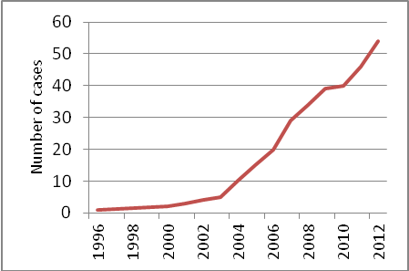

2. Number of cases initiated per year

Starting from 2004, Dutch claimants initiated between five and nine cases per year (with the exception of 2010 when only one case was brought).

The Netherlands ranked second in terms of cases brought by the end of 2012. The United States topped the list, with 125 cases. Other countries with investors active in ISDS include Germany (32 cases), Canada (28), France (27), the United Kingdom (15), and Switzerland (12) (all by end of 2012).

Figure 2.1. Dutch cases Figure 2.2. All cases (global)

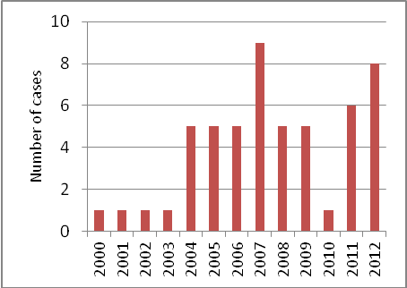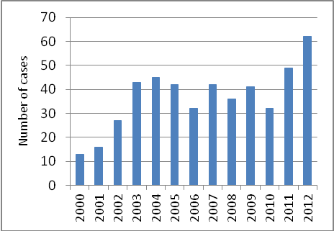

3. Respondent States by geographical region
Dutch claimants initiated most cases against countries in Latin America (35 per cent), in the EU (30 per cent) and in Asia (26 per cent). So far, there have been no cases by Dutch claimants against a North American country.
A comparison to the global figures reveals that Dutch claimants initiate a larger share of cases against other EU Member States.
Figure 3.1. Dutch cases Figure 3.2. All cases (global)

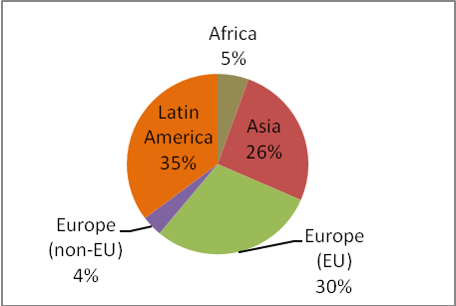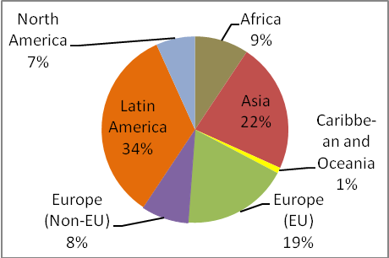

4. Most frequent respondent States

The most frequent respondents in Dutch cases differ from those in the global statistics: only Venezuela and the Czech Republic appear on both lists. For Dutch cases, Venezuela tops the list (13 cases), followed by the Czech Republic (6 cases).

In 2008, Venezuela unilaterally terminated its BIT with the Netherlands. Under the terms of the treaty, the BIT continues to apply to investments made prior to the termination for another 15 years.

Figure 4.1. Dutch cases Figure 4.2. All cases (global)

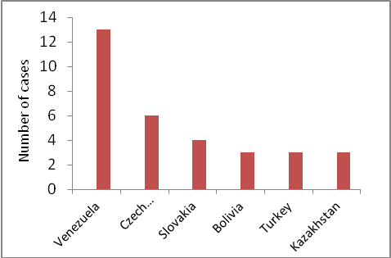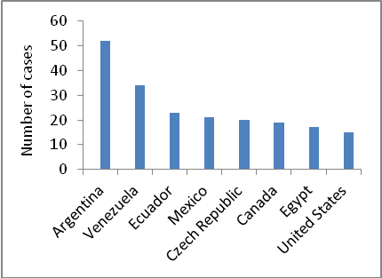
5. Respondent States by level of development (UN classification)

Approximately three quarters of all Dutch cases were filed against developing countries and transition economies. This largely matches the global picture, albeit Dutch cases display a slightly larger share of cases against developed countries. This is due to a higher amount of cases by Dutch claimants against other EU Member States (see also Figure 3 above).

Figure 5.1. Dutch cases Figure 5.2. All cases (global)

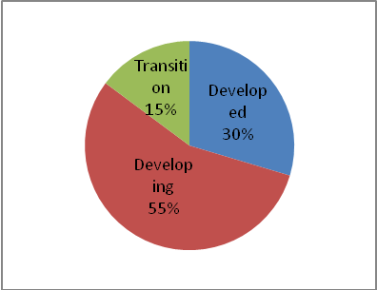

6. Respondent States by level of income (World Bank ranking)

Seventy-five per cent of all Dutch cases have been brought against middle-income countries. Of these, two thirds are against upper-middle-income countries. A quarter of all cases are against high-income economies and only two per cent are against low-income ones. This data roughly corresponds to the global case statistics.

Figure 6.1. Cases by Dutch claimants Figure 6.2. All cases (global)
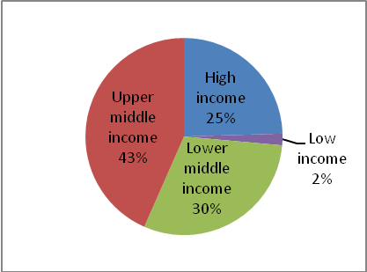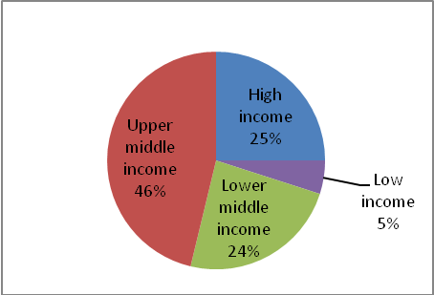

7. Ultimate ownership of Dutch claimant companies

In three quarters of ISDS cases based on Dutch IIAs, the ultimate owners of the claimant companies are not Dutch themselves. None of these foreign-owned but Netherlands-based claimant companies appear to engage in substantial business activities in the Netherlands. Taking Dutch operations of the ultimate foreign owner as a whole (i.e. looking not only at the claimant company but at all Dutch subsidiaries of the given foreign owner), in slightly over one-third of cases the relevant foreign owner has physical presence and appears to carry out business activities in the Netherlands.

Figure 7.1. Ultimate ownership: Dutch cases

Ultimate owner of claimant company Claimant company's foreign owner: operations
(Per cent) in the Netherlands (Per cent)

Source: Methodology developed and analysis undertaken by UNCTAD in collaboration with the Dutch Ministry for Foreign Affairs. Based on the ORBIS Database by Bureau van Dijk and other publicly available sources.
Notes:
* Two cases, for which it was impossible to identify the ultimate owners of the claimant companies, were assumed to be Dutch.
** For the purposes of this study, a company is considered to have substantial business activity if (1) it has a production facility, research laboratory and/or office in the Netherlands, and (2) employs at least 10 employees. When a company does not meet these requirements it is considered not to have substantial business activity.

8. Economic sectors involved

Almost 60 per cent of all Dutch cases concerned investments in the tertiary (services) sector. Services industries that feature frequently in Dutch cases are financial services (banking, insurance and other), the generation and supply of electricity and telecommunications.

The primary sector (mining, agriculture) and the secondary sector (manufacturing) account for approximately equal shares in the overall distribution of Dutch cases. In the primary sector, the oil and gas industry is a clear leader in the number of cases, while manufacturing covers a broad range of activities (beverages, cement, metals, textiles, and other products).

The sectoral distribution of Dutch cases is largely consistent with the global trend of sectoral distribution. Globally, however, cases relating to the services industries take a somewhat smaller share, while cases in the primary industries, particularly in oil and gas and mining, take a somewhat larger share.

Figure 8.1. Dutch cases Figure 8.2. All cases (global)

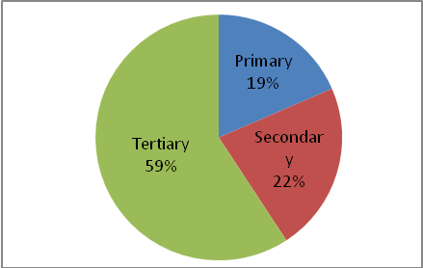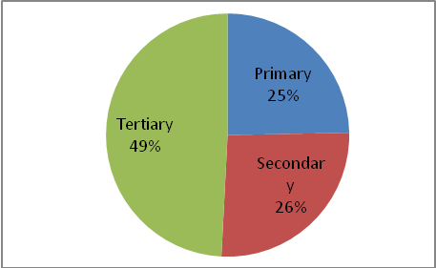

9. Distribution of cases by arbitral rules

In line with global trends, more than two-thirds of known Dutch cases were brought under the ICSID or ICSID Additional Facility rules. Almost all remaining cases were submitted under the UNCITRAL Arbitration Rules (except one case arbitrated under ad hoc rules).

Figure 9.1. Cases by Dutch claimants Figure 9.2. All cases (global)

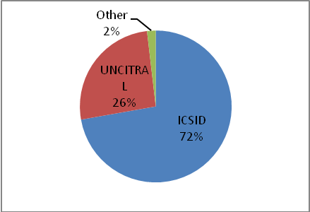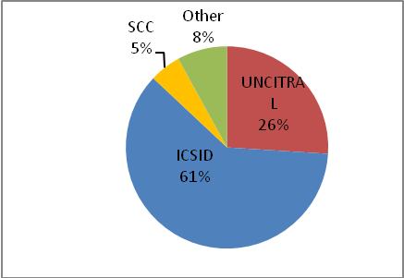

10. Outcomes of cases (merits and jurisdiction)

Out of the 37 concluded Dutch cases, 17 were settled by the disputing parties. Not taking into account the 3 discontinued cases and the special case of Rompetrol v. Romania (where a treaty breach was found but no damages awarded), the number of settled cases constitutes slightly more than half of all concluded cases. This contrasts with the global picture where only one quarter of all cases ends up in a settlement.

Similarly, taking into account the discontinued case and the special case of Rompetrol, out of the 37 concluded cases, slightly less than one third (11) were decided in favour of the respondent State (either at the jurisdiction or at the merits stage).

Figure 10.1. Dutch cases Figure 10.2. All cases (global)

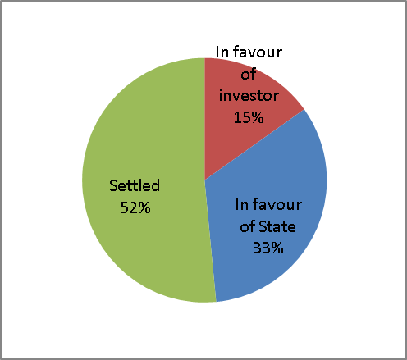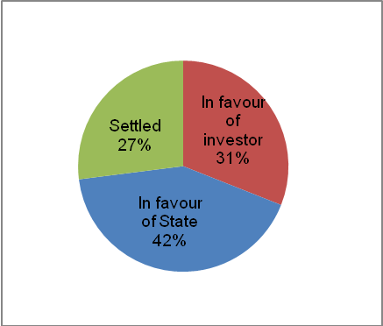

11. Outcomes of cases that completed the merits stage
Taking the outcome of the 12 cases that completed the merits stage, the tribunal found breaches in 8 of them, while in 4 of them no treaty breach was found. Dutch cases therefore show a 2 to 1 ratio in favour of the investor.

The results in Dutch cases are slightly more favourable for Investors compared to the global figures. However this data have to be interpreted with caution, given the small number of Dutch cases in the sample (12).

Figure 11.1. Dutch cases Figure 11.2. All cases (global)

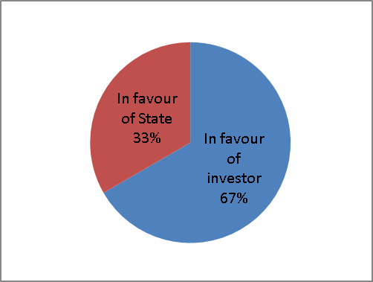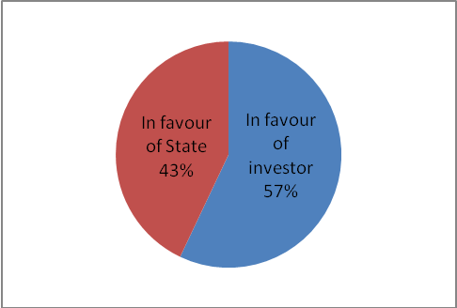

12. Treaty provisions invoked by the investor

In most cases, investors claimed that the challenged State conduct violated several treaty obligations at the same time. For the sample of Dutch cases where the relevant information is available (28 cases), the treaty provisions most frequently invoked by investors are the following:

- the prohibition of non-compensated expropriation of investments (both direct and de facto);
- the obligation to grant investors and their investment FET;
- the prohibition of unreasonable, arbitrary and discriminatory measures;
- the obligation to afford full protection and security to investments; and
- the obligation to observe commitments undertaken by a State with respect to specific investments ("umbrella" clause).

Other, less frequently, invoked provisions include treaty clauses on non-discrimination (national treatment and most-favoured-nation treatment) and the obligation to allow investors the free transfer of investment-related funds.

Figure 12.1. Provisions invoked: Dutch cases

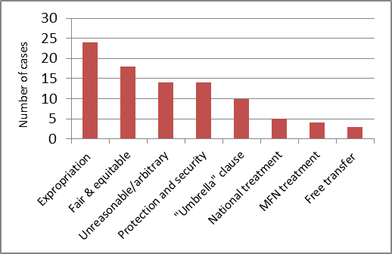

13. Treaty provisions breached

Treaty violations were found in eight of the 12 disputes in which the tribunal considered the merits. In 5 cases, tribunals found a violation of the IIA's provision on expropriation, followed by the FET clause (4 cases), the prohibition of unreasonable and arbitrary discrimination (3 cases) and the umbrella clause (2 cases). It has to be noted, that a tribunal can find more than one treaty breach per case. Aside from the four provisions included in the chart, tribunals in Dutch cases have not found violations of any other provisions invoked by claimants.

Figure 13.1. Provisions breached: Dutch cases

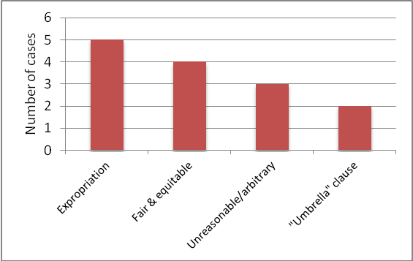

PART II. REVIEW OF SELECTED CASES

This Part reviews provides the results of the review of 21 selected Dutch cases, chosen with a view towards obtaining a balanced representation in terms of:
- level of development of respondent State (UN): developed (10), developing (8), transition (3);
- level of development of respondent State (World Bank): high income/OECD (8), low income (1), lower middle income (4), upper middle income (8);
- geographical region of respondent State: Europe (EU) (10), Latin America (4), Asia (4), Africa (2), Europe (non-EU) (1);
- economic sectors involved: primary (mining and agriculture) (2), secondary (manufacturing) (6), tertiary (services) (13);
- size of claim, ranging from 5 million USD to 30 billion USD;
- outcome of the case: settled (7), in favour of the State (5), in favour of the investor (4), pending (4), discontinued (1).

For the 21 cases selected, UNCTAD undertook further analysis, complementing the information already available in UNCTAD's ISDS database with additional insights. The objective was to identify the type of government conduct that has been challenged, the policy dimension that has come to play, the outcome of the dispute and the reactions of the disputing parties (in so far as information is available), all of which is presented in a table format below (Annex 2).

Initial findings:

- The circumstances surrounding each case are highly individualized.
  - Some cases involve "classic" scenarios such as direct expropriations (of concessions, enterprises or land) or breaches of investor-State contracts.
  - Others raise more unique issues, e.g. host governments being accused of unsubstantiated criminal prosecution of investors or driving an enterprise into bankruptcy.
  - A number of cases brought against former socialist States (Czech Republic, Georgia, Poland, or Slovakia) address issues related to the countries' economic transition (e.g. related to privatisation, economic reforms or issues arising from the country's accession to the EU).
  - Some cases involve public services or other social issues, such as the provision of water (Aguas del Tunari v. Bolivia), health insurance policy (HICEE v. Slovak Republic, Achmea v. Slovak Republic) or waste management (Novera v. Bulgaria).

- Claims under Dutch BITs are primarily brought by companies (legal persons) but there are also examples of claims by individuals (physical persons).
  - Funnekotter v. Zimbabwe and Oostergetel v. Slovak Republic are examples of cases brought by physical persons.

- The types of the companies bringing cases under Dutch BITs vary.
  - Some of the cases were brought by major Dutch companies (e.g. Eureko/Achmea).
  - Some of them were brought by Dutch claimant companies which are part of major non-Dutch transnational corporations (TNCs) (e.g. ConocoPhillips, Holcim or Mittal Steel).
  - Others were brought by smaller and practically unknown companies (e.g. K+ Venture Partners or KT Asia).

- Some cases illustrate systemic ISDS problems.
  - CME v. Czech Republic and Offshore Power v. India are examples involving parallel claims arising from the same facts (e.g. brought by different companies in a corporate chain and adjudicated by separate tribunals).
  - Saba Fakes v. Turkey and KT Asia v. Kazakhstan are examples of nationality planning by a foreign investor with a view to obtaining BIT protection.

- Some proceedings are confidential which makes it difficult or impossible to obtain information about those cases.
  - While arbitral awards are increasingly made available to the public, other arbitration related documents (e.g. request for/notice of arbitration, parties' written submissions, etc.) tend to be confidential.
  - For most settled cases, the terms of settlement are not disclosed (e.g. Aguas del Tunari v. Bolivia, Offshore Power v. India, etc.).

- While the sample of 21 ISDS cases analysed here only includes four where monetary amounts were awarded, it can be noted that this includes amounts of 12 million USD (Funnekotter v. Zimbabwe), 25 million EUR (Eastern Sugar v. Czech Republic), 28,4 million USD (Achmea v. Slovak Republic) and 270 million USD (CME v. Czech Republic).
  - For all of the Dutch cases in which damages were awarded, the range spans from 0,5 million USD (FEDAX v. Venezuela) to the above-mentioned 270 million USD.

- The amount of damages awarded to investors can be significantly lower than the amount they claim.
  - In Eastern Sugar v. Czech Republic, for example, the investor claimed 123 million EUR and was ultimately awarded 25 million EUR. In CME v. Czech Republic, the investor claimed 495 million USD and was ultimately awarded 270 million USD.

- One settled case suggests that large pay-outs to investors may be involved.
  - Eureko v. Poland is the case in point, involving a 6 billon USD settlement.

- Some information is available about investors' and governments' reactions to the outcome of a particular case, although such information is not systematically recorded anywhere.
  - Some investors continued their operations in the host country (e.g., Rompetrol v. Romania), others left the country (e.g., Itera v. Georgia, Funnekotter v. Zimbabwe).
  - In terms of States' actions, Bolivia denounced the ICSID Convention in 2007 and Venezuela terminated its BIT with the Netherlands in 2008 and denounced the ICSID Convention in 2012.

PART III. CONCLUSIONS

Dutch investors (mostly companies and only rarely individuals) rank highest in the European Union, and second highest in the world (after the United States), as frequent claimants in ISDS proceedings.

To some extent, this can be explained by the significant number of BITs signed by the Netherlands, although a few other EU Member States including Germany, the United Kingdom and France have more extensive BIT networks. Another possible explanation is the frequent use of Dutch-incorporated entities as intermediaries in making transnational investments by non-Dutch companies. Indeed, this report has shown that in around three quarters of Dutch cases the ultimate owners of the claimants are not Dutch themselves. Incorporation of a company in the Netherlands is sufficient to benefit from Dutch BITs; no substantive business operations in the country are required.

In terms of most other indicators (geographical region of respondent States and their development status, economic sectors affected, arbitral rules used, etc.), Dutch cases do not display any significant deviations from global statistics. However, compared to global averages, Dutch claimants bring more arbitrations against EU Member States (intra-EU disputes) and settle a higher share of cases before the arbitral award is issued.

The circumstances of each case are highly individualized. In most disputes, the claimants argued that their investment had been directly or indirectly expropriated without compensation and/or that the host State had breached the “fair and equitable treatment” standard.

While this study offers a host of information on Dutch ISDS cases, some proceedings are fully confidential and information about others is patchy. Similarly, little is known about the terms of settlements. This is even more so with respect to investors' and governments' reactions to the outcome of arbitrations (e.g. whether investors leave the host State as a result of falling out with the government). This type of information is not systematically recorded anywhere and is too fragmented for a meaningful analysis.

Given the preliminary nature of data for the disputes initiated in 2013, those cases are not included in the statistical analysis.
For analyses of awards and global trends in ISDS, see UNCTAD's recurrent IIA Issues Notes giving annual updates, entitled "Recent developments in investor-State dispute settlement (ISDS)". For the review of 2012 developments, see http://unctad.org/en/PublicationsLibrary/webdiaepcb2013d3_en.pdf; for the review of 2013 developments, see http://unctad.org/en/pages/newsdetails.aspx?OriginalVersionID=718.
The 6 cases which were initiated in 2013 are: Antin Infrastructure Services Luxembourg S.à.r.l. and Antin Energia Termosolar B.V. v. Kingdom of Spain (ICSID Case No. ARB/13/31); Isolux v. Spain (Stockholm Chamber of Commerce); Charanne and Construction Investments v. Spain (Stockholm Chamber of Commerce); Natland Investment Group N.V., Natland Group Limited, G.I.H.G. Limited, and Radiance Energy Holding S.A.R.L. v. The Czech Republic (UNCITRAL); U.S. Steel Global Holdings I B.V. (The Netherlands) v. The Slovak Republic (UNCITRAL), Spentex Netherlands B.V.v. Republic of Uzbekistan (ICSID Case No. ARB/13/26)
For example, the Permanent Court of Arbitration (PCA) which administers a large number of ISDS cases brought under UNCITRAL rules, reported that by the end of 2013, the total number of PCA-administered ISDS cases amounted to 99, of which only 23 were non-confidential.
Where a case is brought by several claimants, at least one of them is of Dutch nationality.
The ECT is a plurilateral agreement, to which the Netherlands is a party, which includes a chapter with BIT-like provisions and is applicable to investments in the energy sector.
To date, all known ISDS cases against Canada and the United States have been brought pursuant to the North American Free Trade Agreement (NAFTA).
This data corresponds to data given in UNCTAD's IIA Issues Note No 1, 2013, "Recent developments in investor-State dispute settlement "(ISDS)", noting that the IIA Issues Note reports on the total number of respondent States facing cases (per country group/level of development) and not on the total number of cases brought against respondent States (per country group/level of development).
The information in this chart is based on the analysis of 61 Dutch cases initiated by the end of 2013 (not 54 Dutch cases initiated by the end of 2012, as in the rest of Part I). The four cases, in which claimants were physical persons of Dutch nationality, are not included in the chart.
The results of the 37 concluded cases are as follows (see also Annex 1): in 7 cases the tribunal declined jurisdiction, in 4 cases the tribunal ruled in favor of the State on the merits, in 5 cases the tribunal ruled in favor of the investor, in 17 cases, the disputing parties settled, 3 cases were discontinued cases for reasons other than settlement, and in 1 case (Rompetrol v. Romania) the tribunal found that there was a treaty breach but did not award damages, as the claimant had failed to establish economic loss).
The 17 settled cases are: Saluka v. Czech Republic, Aguas del Tunari v. Bolivia, Eureko v. Poland, Trinh Vinh v. Vietnam, Offshore Power v. India, ABN Amro v. India, K+ Venture Partners v. Czech Republic, Mittal Steel v. Czech Republic, Shell v. Nigeria (2006), Eni Dacion v Venezuela, Itera v. Georgia (2008), CEMEX v. Venezuela, Itera v. Georgia (2009), Slovak Gas v. Slovak Republic, Interbrew v. Slovenia, Shell v. Nigeria (2007), Millicom v. Senegal.
The 7 cases where the Tribunal declined jurisdiction are (in chronological order): TSA Spectrum v. Argentina, Azpetrol v. Azerbaijan, Saba Fakes v. Turkey, Alapli v. Turkey, HICEE v. Slovak Republic, KT Asia v. Kazakhstan, Highbury International v. Venezuela.
The 4 cases decided in favour of the State are (in chronological order): Oostergetel & Laurentius v. Slovak Republik, Investmart v. Czech Republic, Liman Caspian Oil v. Kazakhstan, AES v. Kazakhstan.
It should be noted, that data on "won/lost/settled" has to be handled with care. Not only is information on the content of settlement scarce, but also are "wins" never absolute (e.g., a "win" can come at a high cost of non-compensated legal fees and arbitration expenses).
This chart is based on 33 concluded cases, that is the 37 cases minus the 3 cases discontinued for reasons other than settlement (I&I Beheer v. Venezuela, ETI v. Bolivia, Rail World v. Estonia) so as to match the analysis on the global data. Also not included in the chart is the case Rompetrol v. Romania where the Tribunal found that there was a treaty breach but the claimant failed to establish economic loss, and thus no compensation was awarded.
As mentioned above, the global statistics on cases discontinued for reasons other than settlement is being currently verified and is not included in this chart.
The 12 cases that completed the merits stage are (in chronological order): FEDAX v. Venezuela, CME v. Czech Republic, Saluka Investments v. Czech Republic, Eureko v. Poland, Eastern Sugar v. Czech Republic, Funekotter v. Zimbabwe, Rompetrol v. Romania, Oostergetel & Laurentius v. Slovak Republik, Investmart v. Czech Republic, Liman Caspian Oil v. Kazakhstan, ConocoPhilips v. Venezuela, AES v. Kazakhstan.
The 8 cases where the tribunals found breaches include (in chronological order): FEDAX v. Venezuela, CME v. Czech Republic, Saluka Investments v. Czech Republic, Eureko v. Poland, Eastern Sugar v. Czech Republic, Funekotter v. Zimbabwe, Rompetrol v. Romania, Conocco Phillips v. Venezuela.
No breaches of the BIT were found in the following 4 cases: Oostergetel & Laurentius v. Slovak Republik, Investmart v. Czech Republic, Liman Caspian Oil v. Kazakhstan, AES .v. Kazakhstan.
The 8 cases where the tribunals found breaches are (in chronological order): FEDAX v. Venezuela, CME v. Czech Republic, Saluka Investments v. Czech Republic, Eureko v. Poland, Eastern Sugar v. Czech Republic, Funekotter v. Zimbabwe, Rompetrol v. Romania, Conoco Phillips v. Venezuela. It has to be noted that this includes 3 cases which were won by the investor, 3 settled, 1 pending and 1 not counted in terms of "won/lost". In the pending case (ConocoPhillips v. Venezuela) a treaty breach was found but the calculation of damages was postponed to a separate phase of the arbitration. In Rompetrol v. Romania a treaty breach was found, but no damages were awarded (due to the claimant's failure to establish its loss). The case is therefore not counted in the "won/lost" statistics.
For review of treaty practice and arbitral awards involving expropriation provisions in IIAs, as well as policy recommendations, see UNCTAD's Pink Series Sequel on "Expropriation", available at: http://unctad.org/en/Docs/unctaddiaeia2011d7_en.pdf, as well as Section 4.5 of the IIA Table in "UNCTAD' Investment Policy Framework for Sustainable Development (IPFSD)", available at http://unctad.org/en/PublicationsLibrary/diaepcb2012d5_en.pdf.
For review of treaty practice and arbitral awards involving FET provisions in IIAs, as well as policy recommendations, see UNCTAD's Pink Series Sequel on "Fair and Equitable Treatment", available at: http://unctad.org/en/Docs/unctaddiaeia2011d5_en.pdf as well as Section 4.3 of the IIA Table in IPFSD, available at http://unctad.org/en/PublicationsLibrary/diaepcb2012d5_en.pdf.
Often, information is only available through specialised, fee-based sources. For a review of treaty practice regarding transparency in IIAs, as well as policy recommendations, see UNCTAD's Pink Series Sequel on "Transparency" available at: http://unctad.org/en/PublicationsLibrary/unctaddiaeia2011d6_en.pdf; Section 6.3.0 of the IIA Table in IPFSD, available at http://unctad.org/en/PublicationsLibrary/diaepcb2012d5_en.pdf, and the IIA Issues Note on "Reform of Investor-State Dispute Settlement: In Search of a Roadmap", available at http://unctad.org/en/PublicationsLibrary/webdiaepcb2013d4_en.pdf.

