 | Non-paper – European Baseline Requirements | 28.05.2025

In light of the European Commission’s Preparedness Union Strategy, published on March 26, we, the countries of Belgium, Luxembourg, and the Netherlands welcome the Commission’s ambition to put forward recommendations on minimum preparedness requirements and suggest that these be developed in the form of EU baseline requirements (EU BLR) to strengthen resilience across the Union. These non-binding requirements should ensure the continuity of essential and vital functions within the EU and further the efforts of its Member States in this field. Our countries stress the importance of close alignment with NATO’s existing baseline requirements (NATO BLR) to ensure coherence and strategic synergy.

EU Baseline Requirements
The Preparedness Union Strategy proposes to put forward recommendations on minimum preparedness requirements, including a monitoring mechanism, as set out in key action 7. A common framework defined at the EU level for the continuity of the essential and vital functions is not only valuable to enhance preparedness and resilience across Member States, but already foreseen as an objective. This non-paper therefore argues that the Council should start reflections on the way that these key actions should be defined, as to provide input for the Commission’s recommendations. It is our view that if these minimum preparedness requirements are being developed, they should take the form of EU BLR, designed to be complementary to NATO BLR, to enable a coherent and structured framework for the Member States.

In a deeply interconnected Europe, the resilience of one Member State is closely linked to the resilience of all. While the NATO BLR serve as a strong reference point for many countries, some non-NATO EU Member States are also actively engaged in strengthening their national resilience. The objective of establishing EU baseline requirements is not to replace or question these efforts, but rather to provide a common framework that provides the opportunity to include all Member States, independent of NATO membership. This would facilitate coordination, enhance interoperability, and support the development of coherent national resilience plans across the Union, leaving no Member State behind.

To define the specific scope and focus of the EU BLR and ensure their relevance, a thorough analysis of existing legislation should be conducted to identify gaps and possible opportunities. This analysis should build on what already exists at NATO level, while also taking into account what is being done within other international frameworks, such as the United Nations Sendai Framework on Disaster Risk Reduction, to make sure that the developments at EU level complement these existing efforts. In doing so, it is crucial that the EU BLR are designed within the boundaries of existing mandates and with respect for Member States’ national competences. This would enable the EU BLR to close existing gaps and adopt a whole-of-society approach, strengthen coherence between different frameworks, and connect resilience efforts across sectors. It is also important that the establishment of EU BLR builds on existing legislative and strategic EU instruments that already contribute to strengthening the Union’s overall resilience. The aim is to help Member States to navigate complexity without duplication of effort, and making full use of the tools and mechanisms that are already in place.

As a result of this gap analysis of existing efforts and legislation, the EU BLR should define and cover the essential and vital functions of both the EU and its Member States. Although not legally binding, the requirements would cover several sectors of activity that will enable the continued operating of these essential and vital societal functions. The development of EU BLR would benefit two levels in complementary ways:
- At national level, the EU BLR would provide Member States a practical framework, encouraging the complementarity of their actions with each other, and with the EU, and with other organisations such as NATO;
- At EU level, the development of these minimum preparedness requirements within the Union itself, using EU tools and mechanisms, would not only enhance the EU’s own resilience, but also enable it to better support Member States in strengthening theirs.
It is important to note that while existing legislative and strategic instruments at EU level, such as the CER Directive, NIS2, the Hybrid Toolbox, IMERA, IPCR, UCPM, and many more, already contribute to strengthening resilience, they do not in themselves constitute the baseline requirements. Rather, they will support and contribute to their implementation. It is important to capitalise on these existing mechanisms, which already actively contribute to strengthening the EU’s vital and essential functions today, to form a coherent and effective framework.

Complementarity with NATO
With the 2021 Strengthened Resilience Commitment, NATO already agreed to enhance resilience, adopting an integrated and better coordinated approach. Therefore, it is crucial that if minimum preparedness requirements are developed, this does not happen in isolation but in strategic alignment with NATO’s baseline requirements. This facilitates Member States in integrating both NATO BLR and EU BLR seamlessly into one single, comprehensive national resilience plan, thereby promoting efficiency and avoiding redundancy. This idea is also reflected in the Preparedness Union Strategy, which states that if they are to be developed, these minimum requirements should be complementary to the seven NATO baseline requirements where possible, while emphasizing areas specific to EU competences. This may involve a wide set of sectors and stakeholders, reflecting the EU’s comprehensive role.

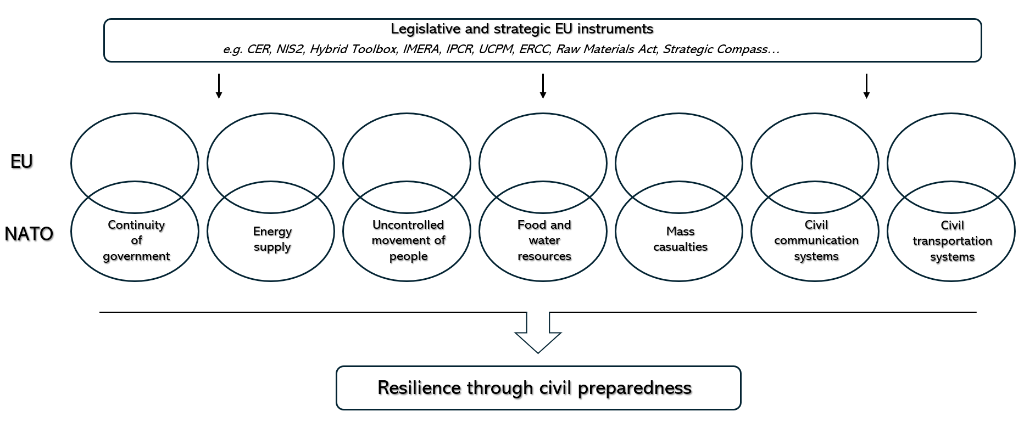

Complementarity between EU and NATO frameworks would also facilitate more effective civil-military cooperation, both at European and national level. Strengthening this cooperation is a cornerstone of the Preparedness Union Strategy, notably through key action 22 “Establish comprehensive civil-military preparedness arrangements”, which calls for a stronger operational cooperation between both institutions in all crisis contexts. Both civilian and military entities must have a thorough understanding of each other’s plans and initiatives. Clear definitions of roles and responsibilities are essential to ensure that civilian and military actors can work together effectively without overlapping or conflicting mandates. In this light, each logic can find its way into the respective plans currently being developed. By ensuring that similar principles, terms and definitions guide the development of EU BLR, Member States can enhance coordination between civil crisis management and defence players. This alignment is equally important with respect to monitoring instruments, where coherence between EU and NATO approaches can help avoid redundancy and minimize the workload for national authorities.

Finally, the existence of both EU and NATO baseline requirements may facilitate more genuine dual use, in terms of investments in infrastructure and capabilities, but also in how those capabilities and systems are organised and mobilised in both civilian and defence contexts. Infrastructure, resources, and systems could be designed and maintained in ways that serve both EU and NATO needs, reinforcing resilience across the board. The EU can play a role in promoting innovation, providing funding options and strengthening links between the defence sector and other civilian industries. Key action 23 of the Preparedness Union Strategy also reflects this objective, with the Commission and the High Representative stating their commitment to ensure that dual-use investments support civilian resilience, societal security, and military needs in a mutually reinforcing manner building on military requirements.

Conclusion
To maximize these benefits, swift and coordinated action is needed. The European Commission’s Preparedness Union Strategy provides a unique opportunity to look into the development of EU baseline requirements. This development should be grounded in a thorough assessment of existing tools and legislation to ensure that the EU BLR are well-defined and clearly targeted. By offering a structured and coherent framework, the EU BLR can help Member States to be better equipped to respond to future challenges, while strengthening alignment with NATO and promoting effective civil-military cooperation. We look forward to the Commission’s recommendations on these minimum preparedness requirements.

NATO - Topic: Resilience, civil preparedness and Article 3
“Adopt minimum preparedness requirements” – Key action 7 in the Preparedness Union Strategy; Action 13 in the Preparedness Union Strategy – Action Plan
“Establish comprehensive civil-military preparedness arrangements” – Key action 22 in the Preparedness Union Strategy; Action 43 in the Preparedness Union Strategy – Action Plan
“Develop standards for civilian-military dual use planning and investment” – Key action 23 in the Preparedness Union Strategy; Action 44 in the Preparedness Union Strategy – Action Plan

